**Singing in the Rain**

**Mountain Day 2015**

**Schedule of Events**

9:00 AM Bag lunches available at Grab & Go in Paresky until 10:30 AM

9:30 AM *Singing in the Rain* begins showing in Paresky Auditorium

10:00 AM 7 Mile Hike on Bellows Pipe trail over Mt. Greylock to Stony Ledge

Meet at Paresky steps, bring your rain gear, lunch and two filled water bottles.

10:30 AM A Cappella performances, donuts, cider, and coffee at Goodrich Café

10:30 AM – 12:00 PM Dancing in the Rain on Paresky Lawn

Courtesy of WCFM, enjoy a good rainy day dance party! BYOUmbrella.

11:00 AM SLIP n SLIDE Townball Like kickball but better. Poker Field

11:00 AM – 1:00 PM Community Lunch in All Dining Halls! No swipe required.

11:30 AM Mountain Day Adventure Race

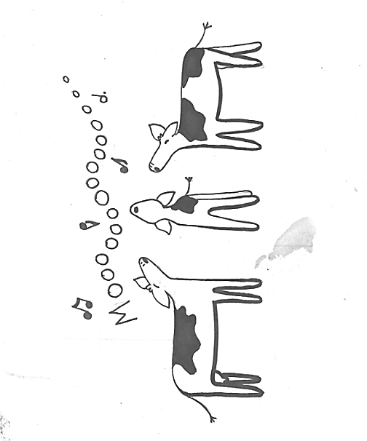Meet at the Paresky steps, bring your lunch, and a filled water bottle.

Must have already pre-registered with Eli Meckler.

12:30 PM Following trips depart for Stony Ledge festivities from Mission Drive:

Roaring Brook Trail 3 miles

Stony Ledge Trail 2 miles (short but steep!)

Hopper Trail 3 miles

Haley Farm Trail 2 miles (short but steep!)

2:45 PM Festivities begin on Stony Ledge!

Performances by student groups, refreshments provided.

Bring a cup and a friend or two, or three…

3:30 PM 2-mile hike down Haley Farm Trail to buses waiting at the Hopper Trailhead.

2-mile hike down Stony Ledge Trail to buses waiting on Rt. 7.

3-mile hike down Hopper Trail to busses waiting at the Hopper trailhead

9:00 PM Polar Bear Swim in the Green River!

Meet at Paresky steps; bring a towel and warm clothes.

If you need transportation to Stone Hill (because you are unable to hike)

please contact Caroline at ccw1! There is limited space available.

For last-minute changes and additions, check http://woc.williams.edu